Water Quality Assessment of the Kenai River Watershed from 2000 to 2023 [DRAFT]
Benjamin Meyer, Kenai Watershed Forum
2023-02-20
Table of contents

Preface
This document is a report on the project, “Water Quality Assessment of the Kenai River Watershed, 2000 - 2023.” It is an update to historical reports summarising available data to date (McCard 2007; Guerron Orejuela 2016).
This draft report is best accessed as an online interactive document at https://kenai-watershed-forum.github.io/kenai-river-wqx-report-v2/, where it can also be downloaded as an Microsoft Word document. All project files and source code are hosted in a public GitHub repository, also accessible at the above URL.
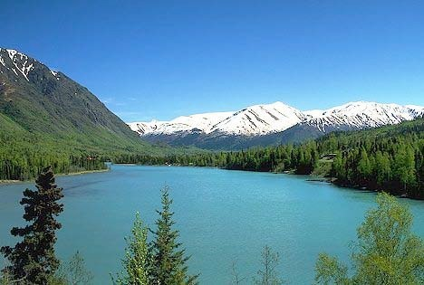
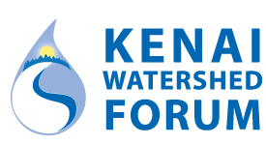

Acknowledgements
This study could not have been completed without the assistance and cooperation of many state agencies including the Alaska Department of Environmental Conservation (ADEC), the Alaska Department of Natural Resources, and the Alaska Department of Fish and Game. The Kenaitze Indian Tribe, Cook Inlet Aquaculture Association, SGS Alaska Laboratory Analytica Laboratories, Kenai Peninsula Trout Unlimited and Taurianen Engineering and Testing also supported this project. Additional cooperation transpired with the United States Forest Service, the United States Fish and Wildlife Service through the Kenai National Wildlife Refuge, the Kenai Peninsula Borough, the City of Soldotna, and the City of Kenai. Finally, many landowners graciously allowed access to the Kenai River and its tributaries from their property.
Thank you to all the staff at the Kenai Watershed Forum that made this project possible. Special thanks to …

Abstract
The Kenai Watershed Forum and several governmental agencies formed a cooperative partnership to collect and analyze water samples from 13 locations along the Kenai River mainstem and from eight of its tributaries every spring and summer from 2000 to 2023. Laboratory analysis was conducted on dissolved metals, total metals, nutrients, hydrocarbons, fecal coliform bacteria, and several other parameters. These results are herein compared to Alaska and federal water quality standards for freshwater aquatic life. [Summarize final results here when available].

Units
Conversions:
- 1 gram = 1000 micrograms
- °F = 9/5(°C) + 32
Unit Abbreviations:
- mg/L = milligrams per liter
- μg/L = micrograms per liter
- CFU/100m = coliform forming units per 100 milliliters
- μS/cm = microsiemens per centimeter
- NTU= nephelometric turbidity unit

Acronyms
Acronyms:
- USEPA (United States Environmental Protection Agency)
- ADEC (Alaska Department of Environmental Conservation)
- DRO (Diesel Range Organics)
- GRO (Gasoline Range Organics)
- RRO (Residual Range Organics)
- BTEX (Benzene, Toluene, Ethylbenzene, and Xylenes)

1. Introduction
This report summarizes water quality data collected between summer 2000 and summer 2023 from 22 sampling locations in the Kenai River mainstem and its tributaries. Local, state, federal, and tribal government entities, as well as several local area non‐profits formed a cooperative partnership so that sampling teams from various agencies were able to collect water samples twice per year, once in the spring and once in the summer, and this effort continues beyond the publication of this report. The locations of the sampling sites are identified with maps, GPS coordinates, and photographs. Trends in the data are highlighted, and the results are compared to the Alaska and federal water quality standards for freshwater aquatic life.
The water quality data focuses on metals, nutrients, hydrocarbons, fecal coliform bacteria, and various field parameters. Arsenic, cadmium, chromium, copper, lead, and zinc are the dissolved metals that have been analyzed, and calcium, iron, and magnesium were reported as total metals. Additionally, the report focuses on the nutrients nitrate and phosphorus. Specifically, the hydrocarbons that were collected and analyzed include diesel range organics, gasoline range organics, residual range organics, benzene, toluene, ethylbenzene, m,p-xylene, and o-xylene. Fecal coliform bacteria, pH, specific conductance, total suspended solids, turbidity, and water temperature are the remaining parameters that have been included in the analysis.
The results are displayed in graphs with associated written analyses and tables. The graphs display the median and variance for each parameter at a specific location, and these graphs are separated depending on whether the data was collected in the spring or in the summer. In some cases, parameters were present in levels that could not be detected by current laboratory analysis, and when this occurred with over 80% of the samples, scatter plots have been displayed omitting the unknown low levels.
[previous reports published in 2007 and 2016]
[Text from 2016 report: A trend analysis was conducted for the following parameters: Lead, Zinc and BTEX; based on the nature of the data, a polynomial line was used because it is the best way to capture and represent the fluctuations in the data.]
Complete data tables can be found in Appendix XXX and XXX, which are organized by parameter and site location, respectively.

2. Study Area

2.1 Description
Located in southcentral Alaska, the Kenai River is part of the Cook Inlet Basin and is linked to the surrounding communities through sport and commercial fishing, tourism, recreation, and the propagation of fish and wildlife (Figure 2.1). Five species of Pacific salmon flourish in the Kenai River Watershed, with sockeye (red) and Chinook (king) salmon as the primary species of interest for harvest in subsistence, sport, commercial, and personal use fisheries (Schoen et al. 2017). The Kenai River his historically produced 80% of the sockeye harvested in Cook Inlet (Dorava and Milner 2000).
Surface runoff, groundwater composition, natural minerals, aquatic plants and animals, and human activities can affect water quality in this area. Potential sources of pollution from humans include gasoline powered boat engines, agriculture, mining, street runoff, and perforated septic tanks (Glass, RL 1999; Reeves et al. 2018; EPA 2011).

2.2 Figures/maps

2.2.1 Online Map of Sample Sites
Access ArcGIS Online map at https://arcg.is/0LXGSf
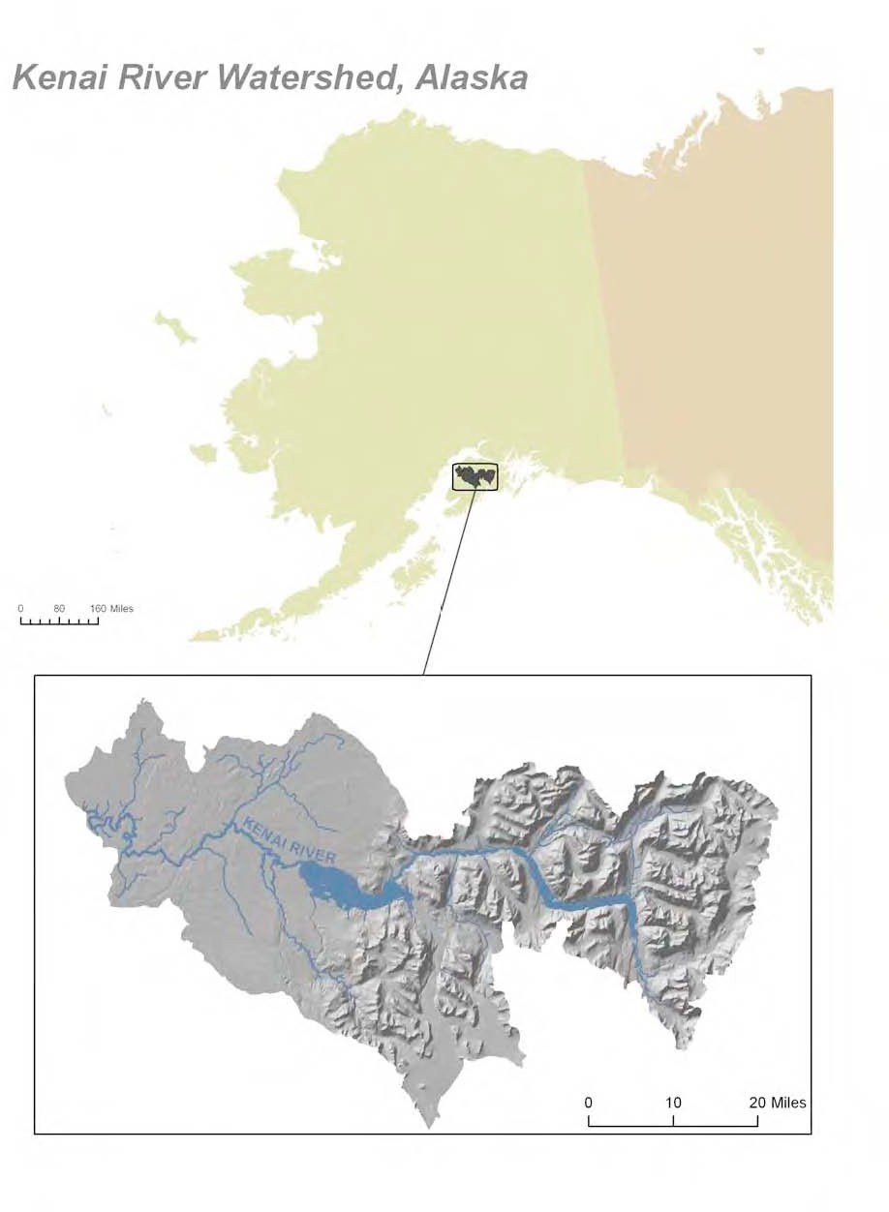
Figure 2.1: Location in Alaska of Kenai River Watershed

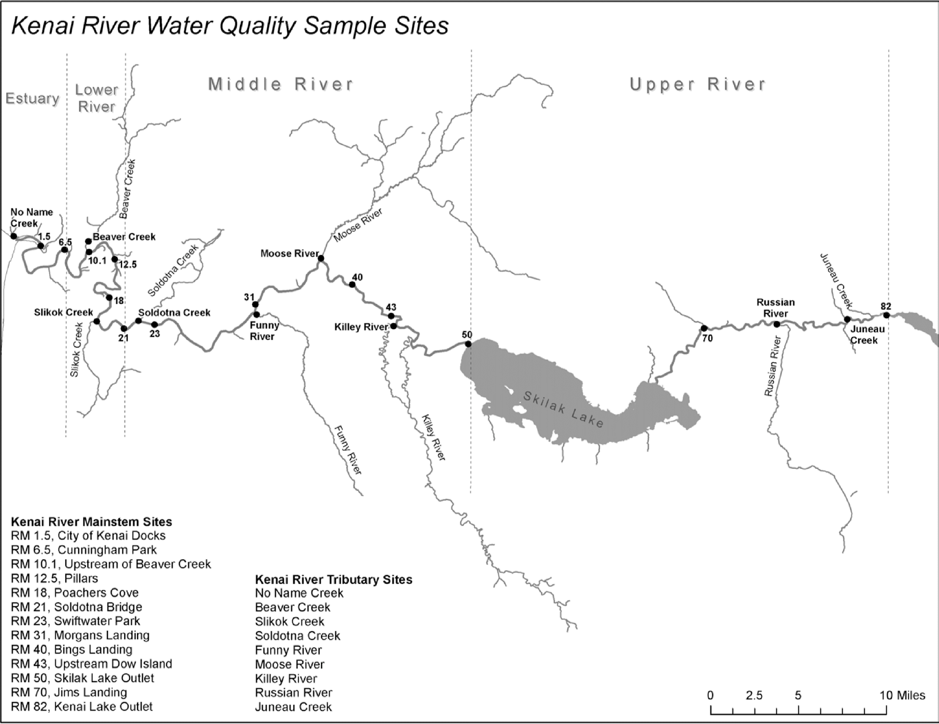
Figure 2.2: Location of water quality sampling sites

2.3 Sampling sites descriptions/photos
Field sampling sites described in Figure 2.2 are introduced below with a photo a coordinates for each location.

2.3.1 Tributary Sites
A brief description of each of the tributary stem field sampling sites, along with coordinates and a photo.

2.3.2 Main Stem Sites
This section will include a brief description of each of the main stem field sampling sites, along with coordinates and a photo.

3. Methods
We collected water samples at 13 locations along the Kenai River mainstem and from eight tributaries near their confluence points (see Figure 2.2). These locations were selected by a technical working group in 1997 to represent diverse regions through the Kenai River watershed’s ambient water quality conditions. Sampling occurred in the spring and the summer each year beginning in summer 2000.
After a half‐day training session, staff from governmental and non‐governmental agencies dispersed between 7:00 AM - 9:00 AM to sampling locations in teams of two or more to collect samples. All samples were collected on the same day, and the timing of the sampling coincided with an outgoing tide, near low tide, to reduce the potential of collecting saline water from Cook Inlet (see Appendix X for timing). Typically, the individual collecting the sample waded into the water until the water level was around two feet deep, and the sample was collected while facing upstream. If the individual collected the sample using a boat, the samples were collected from the bow while the boat faced upstream. The bottles were placed approximately one foot below the surface to collect the water samples and then preserved for transportation to the laboratory. Beginning in spring 2002, two duplicate samples were collected for quality control. These procedures follow the protocols established in a Quality Assurance Project Plan (QAPP) that was originally approved by the ADEC in 2001 and later revised and approved by ADEC again in 2013, 2019, 2020. The QAPP was also reviewed and approved by the Region 10 Environmental Protection Agency office in 2023 [pending as of 2023-02-20]. The QAPP is available from Kenai Watershed Forum [pending as of 2023-02-20].
We used the R programming language in Posit software for all analyses, and generated this report using Quarto publishing software. The report is available both as a downloadable PDF and as an online report at [WEB ADDRESS].
In instances where data was reported as not detected the half of the MDL or MRL [ACRONYMS] was used to estimate the values and run the analysis. The MRL was used because during the early years of the project, the lab only provided this information and not the MDL.

4. Data QA/QC

5. Water Quality Parameters Results

5.1 Interpreting Box Plots
Each of the following graphs display the sampling results for a specific parameter, such as arsenic. Within these graphs, a box and extending lines represent the results reported at each sampling site. A horizontal line within the box corresponds to the median of the data. The box contains 50% of the data and the vertical lines display the minimum and maximum values. Any data points that fall outside of the acceptable range are outliers and are portrayed as small circles (Figure 5.1).
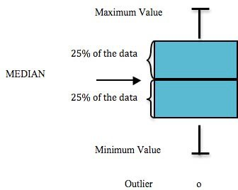
Figure 5.1: Components of a box plot

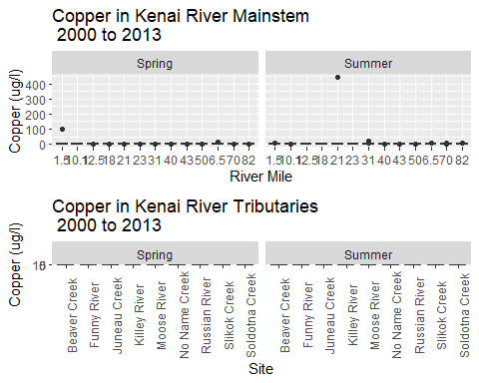

6. Arsenic
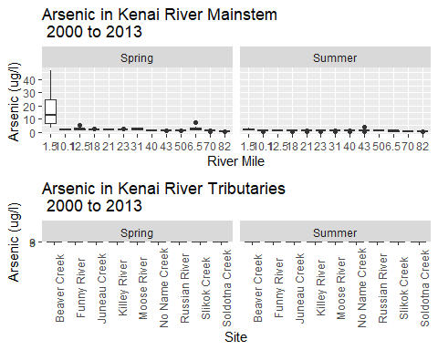

From 2016 report:
Natural sources of arsenic in the Cook Inlet Basin include volcanic ash, glaciation, and mineral deposits. Only a minimal contribution of arsenic results from human activities like wood preservation (Glass and Frenzel, 2001). Arsenic is naturally present as a compound in rocks within the Kenai River Watershed, and as a dissolved metal, it can be acutely or chronically toxic to fish (Glass, 1999). The Alaska Department of Environmental Conservation (ADEC) and the United States Environmental Protection Agency (USEPA) have set the standard at 150 micrograms per liter (µg/L) for freshwater aquatic life chronically exposed to arsenic and 10 micrograms per liter (µg/L) for drinking water (Appendix X) (USEPA, 2014; ADEC, 2008).
None of the samples exceeded the Alaska or federal standard for freshwater aquatic life at any sampling location in spring or summer. The highest level detected in the mainstem was 46.5 µg/L at Mile 1.5 in May 2007, and arsenic was not detected on many occasions below the method detection limit (MDL) of 0.25 µg/L (Table 6). In the Kenai River mainstem, Mile 1.5 had the highest median level in the spring event and summer monitoring event, followed by Mile 6.5 in the spring event and Mile 23 during the summer monitoring event (figures X & X). In the mainstem, higher arsenic levels occurred in the spring samples, while the tributaries levels were higher during the summer with more detected levels between the years 2007-2014 than any of the previous years. (Tables X & X)
The highest concentration on the mainstem occurred at Mile 1.5 where arsenic was detected on every sampling event after 2005, while arsenic was detected on all sampling dates at Beaver Creek, Soldotna Creek, and Moose River. The concentrations of arsenic ranged from a high of 12.8 µg/L in Soldotna Creek in summer 2014 to below the MDL of 0.25 µg/L in many locations. Of the tributaries, Soldotna Creek had the highest median level, followed by Moose River and then Beaver Creek in summer and Soldotna, Beaver and Moose in spring. No Name Creek had the fewest incidences of arsenic detection of all the tributaries. (Tables X & X)
When comparing the arsenic levels to the Alaska Department of Environmental Conservation standards for drinking water, the main stem at Mile 1.5 is the only station that presents multiple exceedances. All exceedances took place during the spring sampling events. (Tables X & X)
Concentrations of arsenic are generally lower in surface streams than in groundwater, which is typically the source of drinking water (Glass and Frenzel, 2001). The USEPA set the criterion for arsenic in drinking water at 10 µg/L because arsenic has been linked to cancer, skin damage, and circulatory problems (USEPA, 2003). Although the levels of arsenic reported in this study do not exceed the national criterion for the health of an aquatic community in freshwater, groundwater may contain concentrations that are hazardous to human health, and all sources of drinking water should be tested for arsenic.

7. Benzene
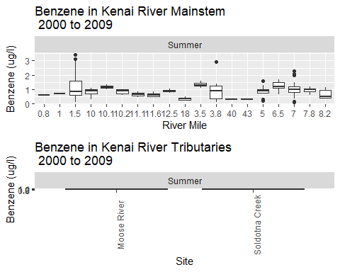

8. Summary
~2 page overall summary here.

References
Dorava, Joseph M, and Alexander M Milner. 2000. “Role of Lake Regulation on Glacier-Fed Rivers in Enhancing Salmon Productivity: The Cook Inlet Watershed, South-Central Alaska, USA.” Hydrol. Process. 14 (16-17): 3149–59. https://doi.org/10.1002/1099-1085(200011/12)14:16/17<3149::aid-hyp139>3.0.co;2-y.
EPA. 2011. “Nonpoint Source Program Success Story, Alaska: Upgrading Boat Motors Reduces Hydrocarbon Pollution.” https://19january2017snapshot.epa.gov/sites/production/files/2015-10/documents/ak_kenai.pdf.
Glass, RL. 1999. “Water-Quality Assessment of the Cook Inlet Basin, Alaska Summary of Data Through 1997.” https://doi.org/10.3133/wri994116.
Guerron Orejuela, Edgar. 2016. “Water Quality Assessment of the Kenai River Watershed from July 2000 to July 2014.” https://dec.alaska.gov/media/16756/kenai-river-baseline-monitoring-report-final-zncuappendix.pdf.
McCard, Jennifer J. 2007. “Water Quality Assessment of the Kenai River Watershed from July 2000 to July 2006.”
Reeves, Mari Kathryn, Margaret Perdue, Lee Ann Munk, and Birgit Hagedorn. 2018. “Predicting Risk of Trace Element Pollution from Municipal Roads Using Site-Specific Soil Samples and Remotely Sensed Data.” Sci. Total Environ. 630 (July): 578–86. https://doi.org/10.1016/j.scitotenv.2018.02.171.
Schoen, Erik R, Mark S Wipfli, E Jamie Trammell, Daniel J Rinella, Angelica L Floyd, Jess Grunblatt, Molly D McCarthy, et al. 2017. “Future of Pacific Salmon in the Face of Environmental Change: Lessons from One of the World’s Remaining Productive Salmon Regions.” Fisheries 42 (10): 538–53. https://doi.org/10.1080/03632415.2017.1374251.

Appendix A — Appendix: Data Review and Uplift

A.1 Introduction
Prior to publishing analysis and interpretation of water quality data, we will ensure that all data that meets QA/QC standards outlined in the current project Quality Assurance Project Plan (QAPP) and is accessible in the appropriate repository.
Water quality data from this project is ultimately destined for the Environmental Protection Agency’s Water Quality Exchange (EPA WQX), formerly EPA STORET. The process of transferring these data to the higher-level EPA repository is referred to as data “uplift.”
The Quality Assurance Project Plan (QAPP) for this project describes data management details and responsible parties for each step of the data pipeline from observation to repository. The 2021 data preparation and review process is published here as an appendix as an example of the process applied annually to each year’s data.

A.1.1 2021 Water Quality Data
In this appendix we will collate 2021 laboratory data from several sources into a single spreadsheet document with a consistent format. The desired end format is a spreadsheet template provided by the EPA Water Quality Exchange. These template files are available to download at https://www.epa.gov/waterdata/water-quality-exchange-web-template-files.
Once the data is collated, it will be evaluated according to a Quality Assurance Checklist provided by the Alaska Department of Environmental Conservation Soldotna office. Field observations that do not meet the quality assurance standards described in the evaluation checklist will not be uplifted to the EPA WQx.
Data that has been uplifted to the EPA WQX is evaluated biannually by the Alaska Department of Environmental Conservation (ADEC) in their Integrated Water Quality Monitoring and Assessment Report.

A.1.1.1 2021 Water Quality Data AQWMS Formatting
The code scripts below assemble water quality data from the three analytical laboratories that partnered with Kenai Watershed Forum for this project in 2021:
- SGS Laboratories (Anchorage, AK)
- Soldotna Wastewater Treatment Plant (Soldotna, AK)
- Taurianen Engineering and Testing (Soldotna, AK)

A.1.1.1.1 2021 Metals/Nutrients Lab Results (SGS Labs)
*Note: the chain of custody documents for SGS Laboratories are integrated into the above downloadable PDF files.

modify code to retain all lab dat for later step? (incl surr, spikes, etc)

A.1.1.1.2 2021 Fecal Coliform Lab Results (Soldotna Wastewater Treatment Plant (SWWTP)/Taurianen Engineering)

A.1.1.1.3 2021 Total Suspended Solids Lab Results (Soldotna Wastewater Treatment Plant (SWWTP))

Appendix A — 2/14/23 go back to FC section and see if sample name is already bad up there

A.0.1 2021 Provisional Results, Prior to Data Review
Results last updated 2023-02-20
The above data sources have been collated in to a single .csv file (available for download) per following guidance in the current Quality Assurance Project Plan.

A.0.2 2021 Data Evaluation
Prior to submission to ADEC, all water quality data must be checked against a series of standard questions in order to evaluate how quality assurance / quality check (QA/QC) processes are instituted. The draft Data Evaluation Checklist Template (available for download below) outlines these questions:

Appendix B — Appendix: Sample Event Timing

B.1 Introduction
Sample event timing for spring and summer events must be chosen with care each year. Sample date occurs on Tuesdays traditionally, and dates must be chosen such that the tide is incoming early in the morning.

B.1.0.0.1 Notes on data sourcing
Data is sourced from the following queries at https://waterqualitydata.us on Feb 24, 2021:
CSV download for sample data: https://www.waterqualitydata.us/portal/#bBox=-151.322501%2C60.274310%2C-149.216144%2C60.738915&mimeType=csv&dataProfile=narrowResult
CSV download for site data: https://www.waterqualitydata.us/portal/#countrycode=US&statecode=US%3A02&countycode=US%3A02%3A122&bBox=-151.322501%2C60.274310%2C-149.216144%2C60.738915&mimeType=csv
Note: these CSV files are excluded from the GitHub repository because they are too large to sync. To reproduce the analysis, download and save these files locally instead. (See the ReadMe file at data/WQX_downloads in the repository).
Using these same queries in the future will download the most current csv files.

B.1.1 Import data
Import data from local csv files
# read in table of known dates from Guerron Orejuela 2016
krbwqm_dates <- read_excel("other/input/sample_dates_tides.xlsx") %>%
rename(activity_start_date = date) %>%
transform(time_max_tide = as.hms(time_max_tide),
time_min_tide = as.hms(time_min_tide)) %>%
select(-data_entry,-link,-sample_date_source,-tide_source) %>%
mutate(julian_day = yday(activity_start_date),
year = year(activity_start_date))

B.2 Dates
# dot plot
krbwqm_dates %>%
ggplot(aes(year,julian_day)) +
geom_point() +
ggtitle("Kenai River Baseline Water Quality Sampling Dates")
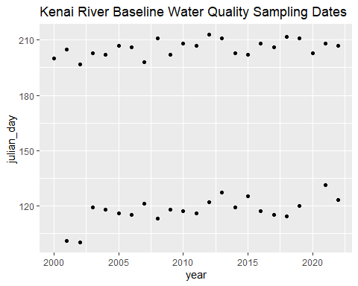
# calculate spring and summer average days
krbwqm_dates %>%
distinct(julian_day,season,year) %>%
group_by(season) %>%
summarise(avg_date = format(as.Date(round(mean(julian_day)), origin = as.Date("2024-01-01")), "%m-%d"),
stdev = round(sd(julian_day)),
n_years = n(),
min_year = min(year),
max_year = max(year))
# A tibble: 2 × 6
season avg_date stdev n_years min_year max_year
<chr> <chr> <dbl> <int> <dbl> <dbl>
1 spring 04-27 7 21 2001 2022
2 summer 07-25 4 23 2000 2022

B.3 Time of Day
# dot plot
krbwqm_dates %>%
ggplot(aes(year,time_max_tide)) +
geom_point() +
facet_grid(.~season) +
ggtitle("Kenai River Baseline Water Quality Sampling Times\nHigh Tides")
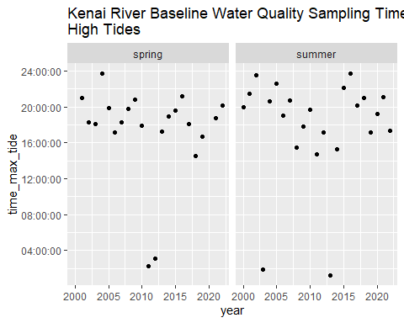
krbwqm_dates %>%
ggplot(aes(year,time_min_tide)) +
geom_point() +
facet_grid(.~season) +
ggtitle("Kenai River Baseline Water Quality Sampling Times\nLow Tides")
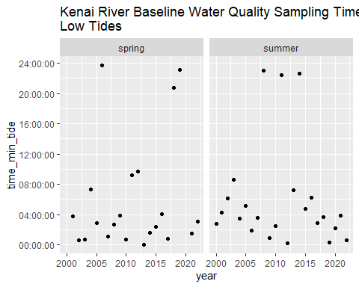
# calculate spring and summer average days
krbwqm_dates %>%
distinct(julian_day,season,year) %>%
group_by(season) %>%
summarise(avg_date = format(as.Date(round(mean(julian_day)), origin = as.Date("2024-01-01")), "%m-%d"),
stdev = round(sd(julian_day)),
n_years = n(),
min_year = min(year),
max_year = max(year))
# A tibble: 2 × 6
season avg_date stdev n_years min_year max_year
<chr> <chr> <dbl> <int> <dbl> <dbl>
1 spring 04-27 7 21 2001 2022
2 summer 07-25 4 23 2000 2022

https://www.kenaiwatershed.org/science-in-action/research-information/water-quality/
https://dec.alaska.gov/water/water-quality/integrated-report/

